How to get the book for this course

The book for this course is *Murach’s Modern JavaScript* by Mary Delameter.

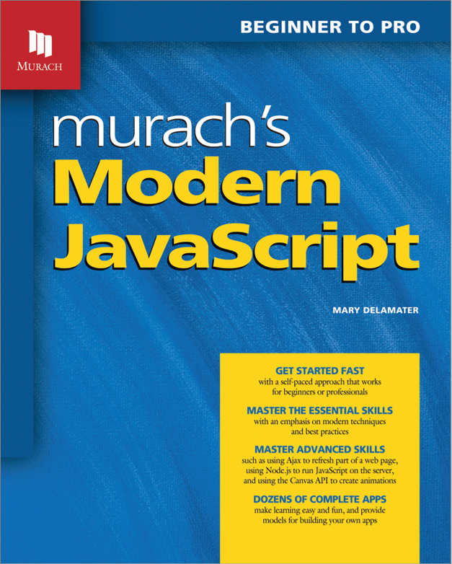

**Print ISBN**: 978-1-943873-14-2

**eBook ISBN**: 9781943873159

If the eBook is included in the course materials provided to you, your instructor will give you the details on accessing it. Otherwise, you can get this book or eBook from the following websites:

### Print book or eBook

[**Murach Books**](https://www.murach.com)

Print book and eBook may also be available from

[Barnes & Noble college bookstore](https://www.bncollege.com/campus-stores/)

[Follett college bookstore](https://www.bkstr.com/efollettstore/home)

### eBook only

[**VitalSource**](https://www.vitalsource.com)

[**RedShelf**](https://www.redshelf.com)

### Print book only

**[Amazon](https://www.amazon.com)**

### International sources

**Canada:** [**Texidium**](https://texidium.com/) for eBooks; follow your instructor’s instructions for access

**UK:** [**Gazelle Book Services Ltd.**](https://www.gazellebookservices.co.uk)for print books

**Australia and New Zealand:** [**WoodsLane Pty. Ltd.**](https://www.woodslane.com.au) for print books

**For additional options:** Please visit [**Murach Books**](https://www.murach.com/customer-service/our-international-distributors)